**Blake Schumann**

Unit 4, 725 Burbridge Road, West Beach 5000 Phone: 0401 361 366

Email: blakeschumann15@gmail.com

**CAREER OBJECTIVE:**

Highly skilled customer service provider and console operator ensuring optimal customer service and strives to be a energetic team member with top notch organizational skills.

**EDUCATION AND TRAINING:**

2010-2014 Cleve Area School

2015-2017 Immanuel College

2018- Bachelor of Sports, Health and Physical Activity @Flinders University

Currently in third year of course

**WORK EXPERIENCE**

I was able to achieve work experience at Vivid Computers on grange road in 2015. It is a computer repairs store and it gave my experience in handling and restoring computers as well as improving my communication skills when talking to new people.

I was able to acquire casual employment at the Cowell Roadhouse in the role of customer service provider and console operator in November 2017. This had help me refine my communication skills as well as giving me experience at working during peak hours of service and being able to run the stock floor individually.

During the of 2019 I attended courses hosted by HG Coffee School where I was able to complete a barista course level 1 certificate (appendix 2) and a bartending basics course certificate (appendix 3). Participating in these courses allowed my refine my hospitality skills an give me experience with working at a fast pace within a close environment.

In November 2019 I gained employment at Muffin Break located at the Adelaide Airport working in costumer service. I was able to gain experience at making coffee and other hot beverages at a fast rate and learned how to make and prepare food for customers.

**PERSONAL SKILLS AND ATTRIBUTES:**

**Communication:**

I have great communication skills which I have gained through playing sport and by being a new student at Immanuel College. At Immanuel College I talked to people of all ages and nationalities and I am able to adapt my speech so I can communicate with many people. This has greatly improved my communication skills with will help me communicate with my fellow coworkers.

**Time Management/Work Ethic**

I have been able to time manage my sport and my schooling with great success. I like to keep organised to ensure that I can fully fulfil my potential in everything that is needed to be accomplished. Through my ninth year of school I was able to hand up all my work before the deadline to my highest possible standards. This demonstrates the strong work ethic I have.

**Willingness to learn**

I know that I don’t have the perfect skills to work in a restaurant and the fact that I have a willingness to learn can give me an advantage as I will be able to learn quicker and develop my skills at a much faster rate which will be needed to make a life in the hospitality industry.

**Leadership Skills**

I have been able to be a leader for a long time and people often walk up to me and ask for advice. I have been given experience by being the captain of my old football team and it have helped my gain knowledge on what it takes to become a leader which would be useful in the kitchen.

I have become a natural leader through being my football team captain and being one of the older ones in my class. I have been able to use my leadership I my school, sport and my personal life through my willingness to help others when it is required. Most people come to me when they need advice or seeking help when needed.

**HOBBIES AND INTERESTS:**

I am an active and energetic individual who enjoys a wide variety of extracurricular activities and interests including numerous sports and recreational activities. In sport I am a member of the Immanuel College football team and Cowell FC football team and I also like to play tennis, basketball and soccer in my spare time. These sports have enabled me to retain my fitness and endurance while also enhancing my competiveness skills. I also love fishing and camping as it is peaceful and I enjoy hanging out with friends.

**REFEREES**

**Referee letter from**

**Mrs. Janette Steff(Manager of Cowell Roadhouse)**

**0400883016**

**(appendix 1)**

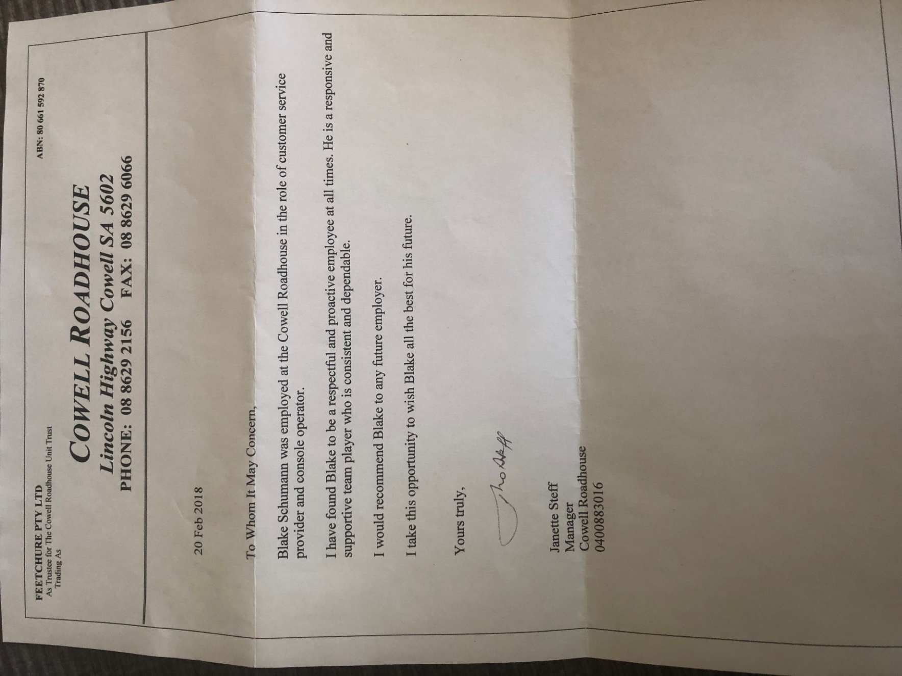

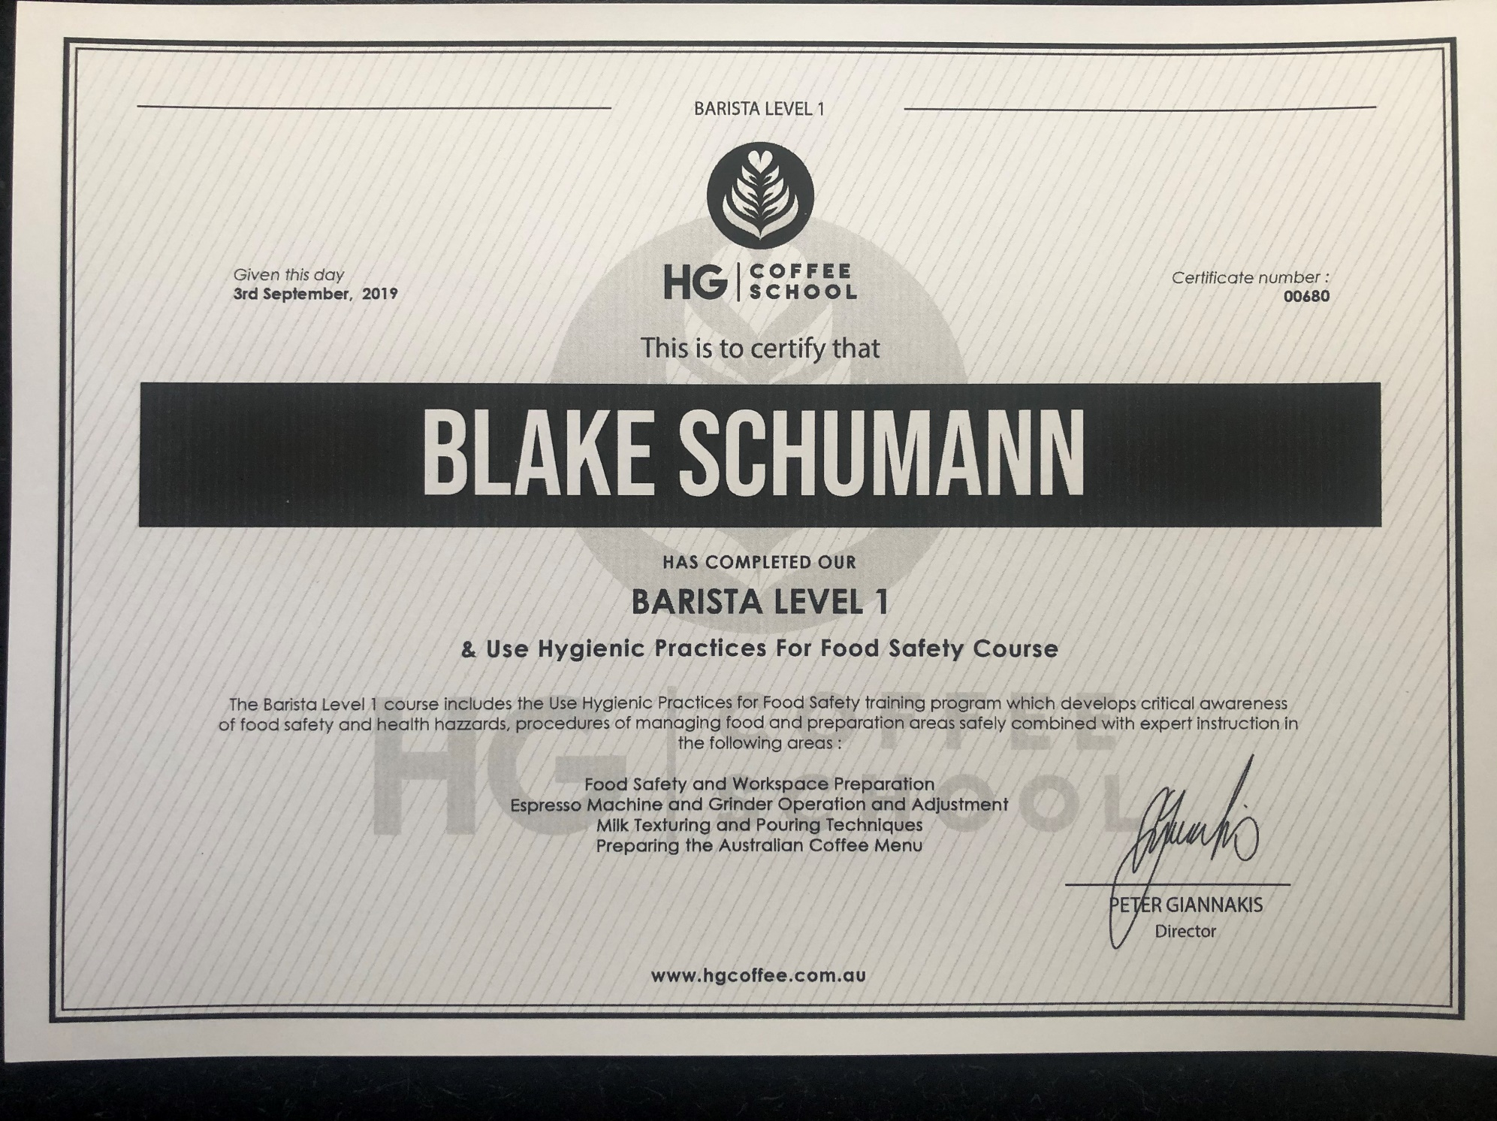**(Appendix 2)**

**(Appendix 3)**

